Why do we use crossorigin?
If the front end is in different port or ip and the backend is no different port or ip
To establish the communication between them we enable cors from backend
For the specific ip
Web browser enforce a security rule called same-origin policy, which prevents website from maliciously reading data from other domains without permission
The crossorigin attribute bypass this block when you intentionally load trusted external resources
purpose of the bundle is the minify, compress, and cleaned the file before it is pushed to the production
Two dependencies
- normal dependency - for production purpose
- dev dependency - for development purpose
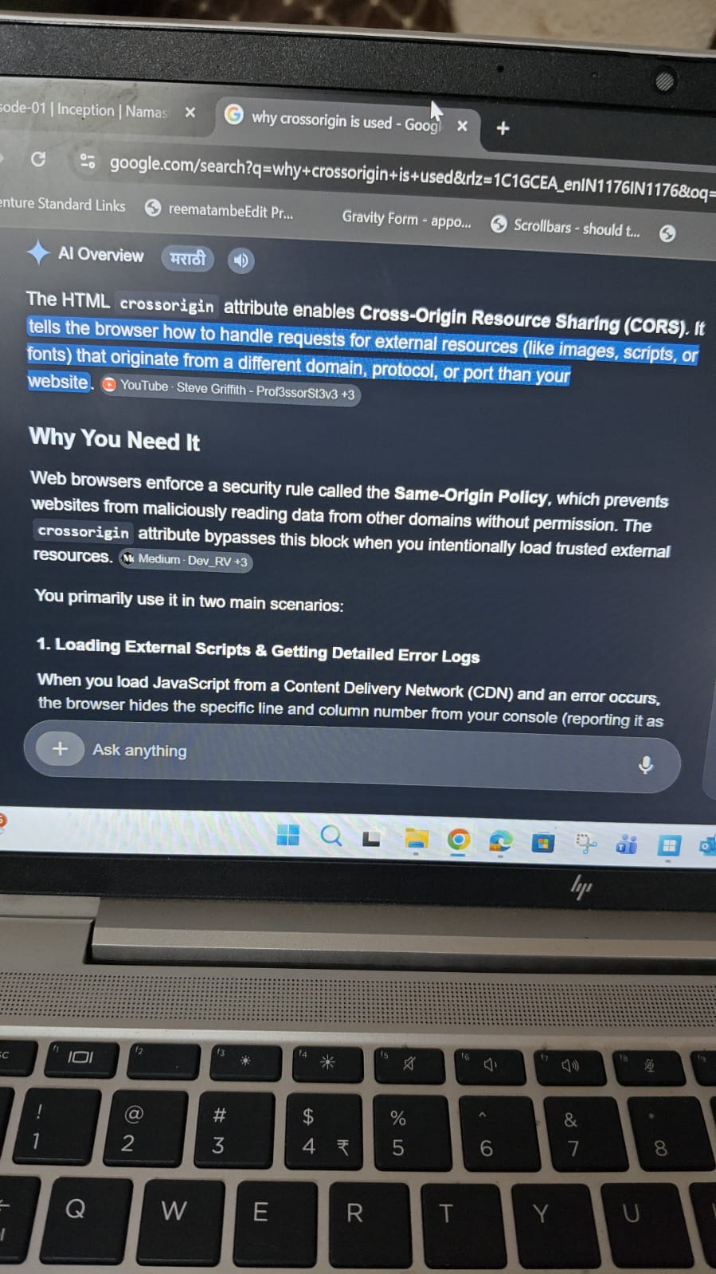
-----------------------------------------------------------------------------------------------
What Parcel(bundler) does?
- Create Dev build
- local server
- HMR
- Caching
- optimization
- tree shaking- remove unused code
- error handling
- differential bundling [ App works on all the browsers] - support for older browser
- code splitting
--------------------------------------------------------------------------------------------
Jsx - JavaScript syntax which is used to create React Element
React component - it is a JS function which returns a react element
Babel - It is Js compiler or transpiler which converts the React Element into a piece of code which the browser or JS engine understand
Component composition - component inside the component
Transitive dependency - Dependency that installs the relative dependency is known as a transitive dependency
Package.json- contains the configuration of npm
To create the local host- npx parcel index.html
To build - npx build parcel index.htnl
To create the local host -npx parcel index.html
If added in script - npm run start
To build - npx build parcel index.htnl
If added in script - npm run build
--------------------------------------------------------------------------------
React Element( Babels convert to React.createElement which browser understands and it is an object) -> ReactDom converts it into html tag and render it into the dom

Props is a property which we pass to the component
Why keys are needed to add : To optimize the render cycle.
For ex we have a container and within that we have items and if new items come and it enters at first place so what react will do if no id is given then new items come then react will re-render all the items. So basically it removes all and re-render all but if we give a unique id then React will know the current one is already there then so only the new one will be render

Config driven Ui - The Ui is driven by config which is sent by backend

There are two ways of importing and exporting
- named
export const varname
import {varname} from file_name
- default
export default Component_name
Import component_name from file_name

Named export - in one page we can add two default export so we can use this

Hooks - It is a normal js function which is given to us by react
The function has some logic behind the scene in the react

useState
- superpower state variable in react
- to create state variable
- maintain the state of the component basically a local state variable inside component
- scope of it is inside the component

Const [test, setTest] = useState([]) <-- Default value is empty arry
To modify we use setTest a second parameter
Whenever a state variable update react will re-render the component
- React uses reconciliation algorithm also known as react fiber
- ex - we have a container and 7 items are there within and our ui changes from 7 to 3 items.
- React creates a virtual DOM
- Virtual dom is not an actual dom, it is a representation of the actual dom
- Basically it is an object React.createElement
- It uses the diff algorithm, finds out the difference between the updated VDom and previous VDom.
- It will calculate the difference and update the dom on every render cycle
- whenever there is change in any state variable, react find out the difference and re-render the component

- React has better render cycle
- page loads - render Ui - api - render again

useEffect
- react gives us useEffect
- two arguments we have, first one as callback function and another is dependency array
- when will it call? After the component is rendered

------
- fetch, returns always the promise
- CORS - browsers blocks from calling the api from one origin to another's Basically if there is origin mismatch the browser blocks the api from calling
- shimmer UI - Skeleton of the existing UI to improve the user experience

Conditional rendering ( Shimmer UI) - Rendering on the basis of condition is known as conditional rendering

Why do we need useState?
- whenever state variable updates, react triggers reconciliation cycle(re-render the component)
- re-render entire component but it will only update the one which has changed by checking the difference from older VDom and newer VDom

When is useEffect called?
- Default behaviour is After every render this is called
- but due to the dependency array this changes the behaviour of the render
- No dependency array - Calls on every render
- if there is an empty dependency array [] - then it is called on initial render and only once even if it re-render again and again
- if something is added then [test] - then it is called every time the test is updated

useState mistakes
- always call hooks inside the component
- use it at the top at the higher level of the component
- inside if else condition, function or array don't use it
Routing
- npm i react-router-dom
- Routing configurations - Information that will tell the browser that what will happen on specific route.
- whenever we are creating route we have to create routing configuration and that we will import {createBrowserRouter}
path: "/"
element: <Compt/>
errorElement: <Compt/>
- For Providing the routing configuration we use RouterProvider component we get it from react-router-dom
- useRouteError - React router dom gives us an access to useRouteError. gives more information about the error. Network error and many more
- To make only the body to change and keep the header and footer static we use children:[configuration path, element]
- We use <Outlet/> component. So the outlet will be filled with the component that has been passed in the children configuration into the Parent Route which is element: <Compt/>
- to create a link we use <Link to="/page"/> component which we get it from react-router-dom and not to use <a/> as it will reload the page

Two types of routing in web app
- client side routing - not making network calls
- server side routing - We make a network call and about us page is coming from the server
- this is the explanation from SPA we have just one page and just the component is getting interchange via client side routing
- we are implementing client side routing, we have our own page
- useParams is a built in routing hook that allows components to read dynamic url parameters from the current route.
- it returns and object of key/ value pairs, where keys match the dynamic segments defined in the router path( eg :id or [is]

Class based component
- It is a class which extends React.Component and it has a render() method which returns the piece of JSX
- React.Component is a class which we got from the React Library
- passing props - constructor will receive the props and we will use super(props)
- Without super props it will through an error
- why we use super props - always we need to use this so anywhere in the class it will be accessible
- in render how we will use this.props.name
- when class is initialised or instantiated the constructor is called and the props are extracted and we can use anywhere using this.props
- The best place to state variable is in the constructor
- this.state is contain a big whole variable which contains a state variable
- this.state {
count : 1;
}
- how to use
this.state.count
- In our class based component if we want to create new state then
- this.state = {
count : 1,
count2 : 2
}
- To update the state variable
this.setState({
count: this.state.count + 1,
})
- whenever the state variable changes it re-renders the component

Lifecycle in React
- how is the component mounted/loaded on the webpage?
- parent component is load then it check it has child component so it start loading the child component
- when class load the constructor is called
- once the constructor then the render method is called
- we have one more method which componentDidMount(), once the constructor is called and then render is called and once the class based component is there on the DOM then this CDM is called
- ParentConstr - Parent Rander - ChildConstr ChildRender - ChildCDM - ParentCDM
- Once the child and parent component is rendered fully then it calls the ParentCDM
- there is something we will be once the component is mounted successfully, the CDM is used to make API call
- why the API called inside CDM?
In useEffect we make an api call, similarly in class based we use CDM. So load - render -api - render so once it is rendered fully it calls the CDM
- Multiple Child - parent constructor - parent render - firstchild constructor - firstchild render - secondchild constructor - secondchild render - Firstchild CDM - secondchild CDM - parent cdm

Lifecycle
- Mounting - updating - unmounting
- when the component is mounted it is mounted in two phases 1) Render phase 2) commit phase
- Constructor and render is Render phase
- Then React updates the dom and CDM is called which is commit phase
- then we make an api called
- this mounting happens for every child every parent every component in react goes through this life cycle method.
- Dom is updated
- Optimizes it by batching the render phase for the multiple child and then it does the commit phase and calls the api
- async CDM(){
fetch()
}
- when the setState is called then the updating cycle starts
- setState update the state variable
- and when the state variable updated the react triggers the render once again.
- and this time state will be updated in this cycle
- and again react will update the dom
- then the update cycle says the ComponentDidUpdate method will be called at the end
- unmounting happens ComponentWillUnmount when the component disappears from the web page or if we go to new page this will be called
- ComponentDidUpdate will call after every update
- we have to use prevProps, prevState in class based. so that's why we use a dependency array in useEffect there may be multiple state variables
- componentWillUnmount - will do the clean up, it is called when we are leaving the page. So lots of things we need to clear when we are leaving the page
- Suppose we have set interval so when we leave the page it still calls so we have to clear the interval. So in componentWillMount we will use clearInterval by using this in the CWU so in the CDM we will use this.timer = set interval()
- in useEffect we will use the return function and in that we will clear the setInterval
return ()=>{}

Single Responsibility principal
- reusable, maintainable and testable when we maintain SRP to the component
- Custom Hooks: it is recommended to create it in a new folder utils and name the file with use* . Hook is something which is normal js function with some super power which is given to us by react. So similarly we will be creating our custom hook and reuse it
- Ex: If the user is online or offline, add event listener, so it needs to be added once and it will only when the user is online or offline. So we will use useEffect with empty dependency

How to improve the performance of the website?
- what can a bundler do? The most important thing is to bundle the file and make it one file.
- we will have only one js file on the browser, so is it good or bad? What if we have thousands of files and make it one. So the size of the js file will increase a lot
- how to optimise this?We have to break down into smaller peaces. We will make a smaller bundle of this file and the process is known as chunking, code splitting, dynamic bundling
- Logical separation of bundles into smaller application
- How to do this?
- we can use lazy loading - When the app loads it won't load the code for that specific component when we go to that page then only it will load. So when required then it should load or it may call as on demand loading
- we will use lazy which we get from the React
- lazy takes call back function and in that we add the import() and within it will take the specific path which we need to do lazy loading
lazy(()=>import("/. path"))
- We will get an error as component suspended while doing synchronous input
- When we click on the page starting it won't have code it will take some time to fetch the data of the page. At that particular time that middle state that causes error
- To handle that state we will use <Suspense> comes from the React
- and we will give fallback so what should react render when the code is not available
- we can pass simmer AI or JSX
- Deploying app over cdn
- Do profiling using react extension or light house
- usecallback usememo react.memo for memorization

Higher Order Component
- Is a function that takes a component and returns a component
- take the component as an input to enhance it and return it back
- HOC is pure function, I won't be making any changes to the existing functionality just will enhance it
- all the react applications have two layers, UI and Data layer
- ui layer is powered by the data layer
- ui means jsx, data is state, props, {}

Controlled and Uncontrolled component
- when it has its own state it is uncontrolled component
- if we take away the power from the component and give it to the parent then it is the controlled component
- parent is the controlled component as the state of child is given to the parent
Also knows as Lifting states up

Example: accordion

Props drilling:
- we have lots and lots of components and passing data from one component to another is a big task
- and data flow in one direction
- what if we have one parent and then at 50th child we need to pass the props
- so it is not a good way to pass one component to another so this issue is known as props drilling
- to resolve this issue we will be using Context api

Context Api
- React gives us access to super power which is known as react context
- Ex:
- 1) we want to show loggedin user name in the header or in any other page so this will be useful
- 2) Black theme

Context Api
- const UserContext = createContext({}) we get it from react
- to access this we use a react hook which is useContext and within we will add the create context
- useContext(UserContext)
- and we can access the provided data
- class based component <UserContext.Consumer> takes callback function where we get the context data
- how can we change the context?
- we have <UserContext.Provider> and use prop as value={}
- we can give it to the entire app or to the specific one

Redux
- redux offers state management
- two libraries
- react-redux
- redux-toolkit

- We have different ways of writing redux. So now we have a modern way of writing redux
- not be using vanila redux
- RTK, now standard way of writing redux
- why we have changed?
- redux stores is too complicated
- lots of packages need to be added to get the redux to do anything useful
- redux requires too much of boilerplate code

Learning Rtk(redux toolkit)
- ex - addtocart

Architecture of redux
- Redux store - It is a big whole object and kept in a global central place and any components can access this, we can read or write the data
- Part of the redux store which is slices. Small portion or redux store
- for eg: we can keep usercart, themcart
- we directly can't modify the cart slice
- so on click of the cart button it dispatches an action and the action calls the function and that function modify the cart
- this function is known as a reducer
- we can say when we click on the cart button it dispatches an action which calls a reducer function which updates the slice of the redux store
- If we want to read the data, how we can get the data from the slice cart and display it in the cart icon
- for this we use selector, to read the data from the store and the selector will display the data on the website
- This is also known as the subscribing to the store
- when we say subscribe to the store it means it is synced to the store. So data in the store can automatically update the website because this component is subscribed to the store it will automatically update

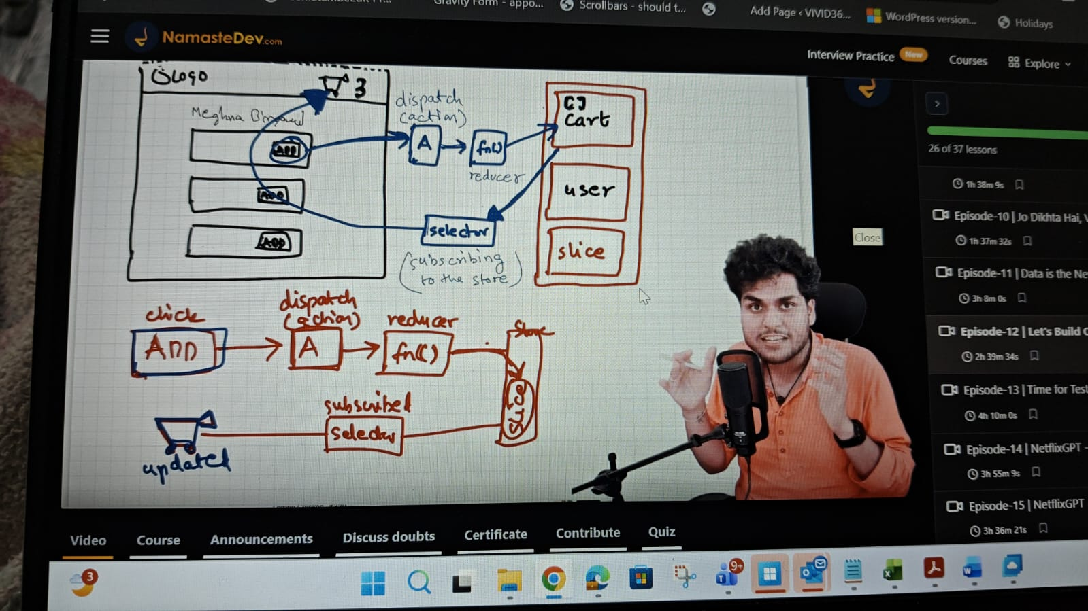
Redux toolkit
- Install @reduxjs/toolkit and react-redux
- build our own store
- connect our store to our app
- create slice (cart slice)
- dispatch(action)
- selector

- we will create a store in utils
- Let's create an appStore we will use the function which configureStore to create our store comes from the redux toolkit
- and in that we will add slices
- And then provide the store to the application
- how to do?
- Provider which comes from react redux
- <Provider store="appStore"></Provider>
- create cart slice which is createSlice comes from rtk. It is function which takes some configuration 1) name 2) initialState 3) reduces
- name = name of the slice
- initialState = what will be the initial state of the slice
- reducer = here we will write the reducer function corresponding to each action, actions are additem, removeitem, updateitem.
- with the help of the reducer we will modify the slice of the store. It get access to initial state and action
- modify state in the bases of the action
- export actions and reducer
- import the reducer on the appStore and that reducer object we will be having the small reducer. Which will be responsible to update the store
- how to display the data so now we will subscribe to the store and for that we will use selector and it is basically a hook which we get from react-redux
- useSelector will give access to the store useSelector((store)=>)
- onclick we will dispatch an action and we have useDispatch hook from react-redux and it is dispatch function which contains the we will add the actions



Shantanu’s
Redux is used to mange global states in react, it's not part of react but a separate library all together

The basic concept is we have a global store which have all our states which we can't directly update, we create slices which we can think it as feature, their can be multiple slices in one app, we create reducer function which have business logic to update the sates, we export this reducer and use useSelector hook and use Dispatch hook to get and update the state

We only use redux for complex state management when their are multiple action to be performed on same state like add, remove update etc

For minor state management we can use context api with useReducer hook

Interview Questions Redux
- 1)whenever doing selector, make sure we are subscribing to the right portion of the store or it will create a performance issue
- extracting the whole store is less efficient so use only the needed portion of the store
- Basically why we need the whole store if we just need the one portion of the store why the other data to be shown when it is not needed
- 2) when in an app store we use reducer and in slice we create multiple reducers so that is why we use reducers.
- and when exporting we are exporting just one so we use reducer
- 3) vanilla redux says don't mutate the state. This was prohibited in the older version and returns the state but in the newer version we have to mutate according to the action also no need to return the state
- it is done on the basis of the immer

